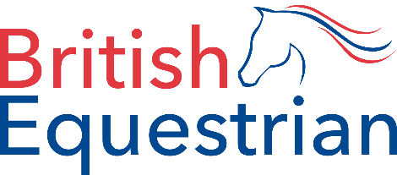
Equine Health Status Declaration for Competition
For use by all British Equestrian member bodies
To be completed for each horse attending any show, training or activity run under the affiliation and rules of any British Equestrian member body between 29 March and 12 April 2021. This form should be completed by the rider or owner of the horse and submitted to the venue 24 hours before arrival at the show or as outlined in the event schedule. Failure to submit a declaration form before will result in the entry being forfeited and the horse will not be allowed on to the venue.
Member body/discipline:
Horse name: |  |  | MB registration number:
UELN number: |  |  | Microchip number:
Rider name: |  |  | MB registration number:
Owner name: |  |  | MB registration number:
Show/venue/activity attending: |  |  | Date of show/activity:
Please confirm your horse currently shows none of the clinical signs listed: | - recent cough of unknown cause  - recent nasal discharge of unknown cause  - enlarged lymph notes  - fever (>38.5ºC)  - recent onset of neurological signs of unknown cause  - diarrhoea
Please confirm the following statements: | The abovementioned horse:  - is not under current investigation for EHV infection.  - has not been in contact with and is not kept on the same premises as a horse known to have or be under investigation for EHV.  - has been resident in the UK for the last 28 days.
Please agree to the following statement: | The horse named above will have its temperature taken prior to travel and will not travel should the temperature reading be >38.5ºC.
Declaration: | To the best of my knowledge, I confirm and agree to all the statements outlined above. I confirm that I am over 18 years of age.
 | Signed:
 | Print name:
Role:
(rider/owner/administrator)
 | Date:

